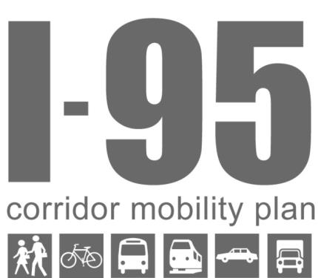Planning Partners' Priority Actions
- FDOT D4
  - I-95 Managed lanes
  - Increasing technical assistance program
  - Data collection - collect multimodal data (i.e. mode splits at critical points. Can be used to set future mode split targets.)

- SFRPC
  - Work with TCRPC to further investigate how improving mobility will enhance economic prosperity and opportunity (Ladders to Opportunity from US DOT guidance)
  - Can work with the GFLA, Beacon Council and PBC Business Development Board to coordinate and work with an emerging alliance of “opportunity” stakeholder who are moving forward based on Recommendations in the Prosperity Plan.

- Broward MPO
  - $100 million in funding over a 5 timeframe to increase multimodal mobility, including sidewalks and biking
  - Corridor studies
  - I-95 Managed Lanes

- SFRTA
  - Tri-Rail Coastal Link: Coordinate with FDOT to move the project into project development.
  - Develop new funding sources/Financial Plan for the existing system and expansion
  - Continue shuttle bus partnering with cities
  - Continue on regional fare coordination and implementation (Easy Card)
  - Outline steps to move Streetcar Studies forward (Fort Lauderdale, West Palm Beach)

- Palm Tran
  - Increase service hours and reduce headways
  - Work to implement Easy Card with SFRTA and BCT
  - Pursue additional funding (revenue) with SFRTA

- Broward County
  - Implementation of Complete Streets plan and projects
  - Annual or biannual meetings to discuss the implementation status of Complete Streets / Complete Streets monitoring report

- Broward County Planning
  - Complete review of Broward County Land Use Plan
    - Transit supportive land use designations will be molded into a multimodal use including higher density

- Port Everglades
  - ICTF implementation (Ships to Rail) as a P3
    - Coordinated effort between FEC and Broward County
  - New performance measure: Compare TEU movement in and out of the port by mode (truck versus rail)
  - Eller Drive project
  - Implement Complete Streets and Context Sensitive corridors

- Broward County Aviation – FLL International Airport
  - Plan for People Mover
  - Update Master Plan
  - Complete runway expansion
  - Recreational path on perimeter road

- City of Dania Beach
  - Adopted CRA/higher density, mixed-use districts
  - Encourage & approve high density/mixed use development downtown (US1 & Dania Beach Boulevard corridors).
  - Ongoing efforts in planning and design of future transit station for the FEC rail.
  - Install bus stop shelters city-wide.
  - Work with MPO to increase bike/ped opportunities downtown.
  - Maintain and expand community bus routes.

- City of Fort Lauderdale
  - Full implementation of TOD and Complete Streets policies through incorporation into the development review process
  - Looking at parking requirement reductions
  - Bike and pedestrian improvements
  - Multimodal connectivity plan
  - Multimodal safety - especially for bicyclists and pedestrians
  - Rail and community bus options, including FEC All Aboard
    - i.e. AAF has access
  - WAVE and Tri-Rail expansion

- City of Hollywood
  - Implementation of Complete Streets program
    - Sidewalk connections
    - Safety

- City of North Lauderdale
  - Taking more steps to implement Complete Streets concepts (bike lanes and sidewalks)
    - Address gaps in the existing Complete Streets network
  - Further commercial development and encourage higher density in certain areas
  - Several multi-use projects/land use changes

- City of Oakland Park
  - Implement Complete Streets
  - Create a downtown TOD with a culinary emphasis
  - Commercial Boulevard business/redevelopment strategy (working with businesses)
  - Work with the MPO to designate a HUB at 38th (FEC)

- City of Pompano Beach
  - MLK context sensitive corridor
  - Adopted Complete Streets guidelines. Will look for implementation grants.
  - Created TOC district for FEC/NTC
  - Corridor studies
  - Increase sidewalk coverage
  - Bus shelters

- City of Wilton Manors
  - Attract future transit station (FEC)
    - Three TOCs have been put in place with mixed-use zoning
  - Looking to implement Complete Streets policy
  - Improve coordination with adjacent jurisdictions for streetscape improvements
  - Looking to implement a Business Improvement District (Wilton Drive and Andrews Ave)

