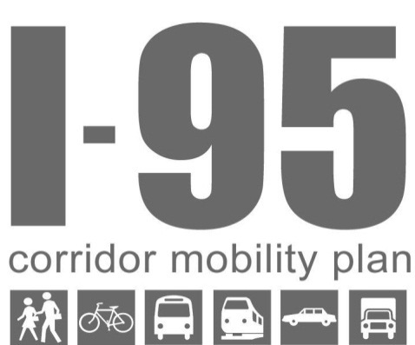
Draft Meeting Summary
Representatives of FDOT District 4 engaged in a series of listening sessions with local governments and transit agencies in late September as part of the I-95 Corridor Mobility Plan.
FDOT met with representatives of the City of Fort Lauderdale on September 30. The group discussed the various strategies the City’s departments are undertaking in pursuit of its land use and transportation goals and the indicators they are currently using (or hope to use in the future) to track success.

Key Themes and Takeaways
- Fort Lauderdale conducted an extensive visioning process with community outreach that culminated in a vision plan, which led to the development of a strategic plan that outlined goals, objectives, initiatives, and performance indicators.
- Fort Lauderdale’s transportation strategies are focused on improving multimodal connections through Complete Streets efforts. The City is implementing low-cost, short-term walkability improvements and developing a citywide multimodal connectivity plan. It is also developing streetscape standards in concert with land use design guidelines.
- The City’s is updating its land development regulations to streamline development approvals in master plan areas, and is continuing to develop design guidelines. The City plans to promote active building design through the use of a form-based code.
- The City has a large database of performance measures, and updates these measures every two weeks. The Strategic Plan includes 142 of these measures and has five-year targets to help achieve the vision for the future.
- Fort Lauderdale coordinates informally with other jurisdictions, as well as with the MPO and FDOT on the development of their multimodal transportation efforts. The City also coordinates with freight railroads and airports.

Action Items
- The I-95 Project Team would like to share the City’s database of performance measures with other local governments as an example of data sources and availability. FDOT will request that the City provide transportation and place related examples of this database.
- FDOT will coordinate with Fort Lauderdale on the selection of locations for annual bicycle and pedestrian counts.
- FDOT will provide the Cypress Creek Tri-Rail Hub report to the City.

Participants
- Glenn Amoruso, Broward County
- Jennifer Barrow, FDOT District 4, Complete Streets Coordinator
- Lois Bush, FDOT District 4, Policy Planning Section Leaders
- Renee Cross, City of Fort Lauderdale, Dept. of Transportation & Mobility, Senior Transportation Planner
- Jessica Dimmick, Renaissance Planning Group, I-95 Corridor Mobility Plan Project Team
- Larry Hymowitz, FDOT District 4, Mobility Coordinator
- Karen Kiselewski, Renaissance Planning Group, Project Manager
- Todd Okolichany, City of Fort Lauderdale, Urban Design & Planning, Principal Planner
- Ella Parker, City of Fort Lauderdale, Urban Design & Planning Manager
- Tom Turberville, FDOT District 4, Strategic Intermodal System & Concept Development
- Enrique Zelaya, Broward County

Discussion
After an initial overview of the I-95 Corridor Mobility Plan project and status update, FDOT representatives and project team members engaged the representatives from the City of Fort Lauderdale in a dialogue on the City’s vision, strategies, and indicators.

Vision and Goals
The City underwent an extensive visioning process within the past year with community outreach meetings, listening sessions, and focus groups. This process generated hundreds of ideas; the top tier items surrounded transportation and connectivity. The community was clear – they want better bicycle and pedestrian connectivity. This process helped City staff to articulate the backdrop for what the community supports. The Vision Plan is available online at the City’s website.
City of Fort Lauderdale Vision Statement
- We are connected. We move seamlessly and easily through a safe transportation system where the pedestrian is first.
- We are ready. We are a resilient and safe coastal community.
- We are community. We are a neighborhood of neighborhoods.
- We are here. We are an urban center and a vacationland in the heart of South Florida.
- We are prosperous. We are a subtropical City, an urban laboratory for education and business.
- We are united. We are a strong and vibrant kaleidoscope of multi-generational cultures, ethnicities, and community partners.
We are Fort Lauderdale, a community of choice. We are the City you never want to leave.
This Vision Plan gave City staff the community support to formulate its goals, and leads into the strategic planning process. Fort Lauderdale adopted the Strategic Plan Press Play Fort Lauderdale in mid September 2013. The Strategic Plan identifies 12 goals, 38 objectives, 191 initiatives, and 142 performance indicators to implement the vision. Many of these efforts support multimodal transportation and transit oriented development.

Current Initiatives & Strategies
The City of Fort Lauderdale has a lot of initiatives in addition to those outlined in its Strategic Plan that all seem to be coming together at the same time.

Multimodal Connectivity
The City’s transportation and mobility department is finalizing a citywide multimodal connectivity plan. Through this effort, the City is examining whether each street has adequate sidewalks, bike lanes, shade, and lighting. This multimodal connectivity plan will help determine the needs list that the City submits to the Broward MPO for its long-range transportation plan (LRTP). City staff explained they now have a comprehensive list of all of the pedestrian, bicycle, and road projects that need to be implemented in the foreseeable future.

TOD Guidelines for Streetcar
The City is developing TOD guidelines as an update to the downtown master plan, which guides development for the downtown area. The City referenced this as “a new chapter” in the master plan.

Complete Streets Manual
Fort Lauderdale has developed a Complete Streets Manual, based largely on the Broward County Complete Streets Guidelines and tailored for Fort Lauderdale. Once adopted, all development plans within the City would need to adhere to this manual. City staff expected policy adoption to occur within only a few days, and on October 1, the City Commission adopted its Complete Streets Policy.

Other Master Plans and Corridor Plans
The City recently prepared a draft plan for land use and design along Broward Boulevard, and will do the same to supplement the street components within the US 1 master plan and the Davie Boulevard master plan. The US 1 master plan looks at streetscapes and determines setback requirements, sidewalk buffers, shared parking, and cross-access easements for pedestrians. The City is encouraging strategies to create a “park once” environment.
The City developed the Central Beach master plan which includes A1A, and the Riverwalk District Public Realm Plan to create a vibrant walkable environment for this public space with river taxis and other amenities. City staff mentioned the South Andrews Avenue corridor is “spurring interest.” The City Commission approved the Marina Lofts development along the Riverwalk in this area. Overlay zoning on South Andrews Avenue made parking for new uses easier to obtain and streamlines the development review process. City staff cited Tap 42, a new restaurant and bar, as an example of the development that has resulted directly from these regulations.
The City has master plans for the three Regional Activity Centers, and is developing design guidelines and streetscape standards for the Northwest Regional Activity Center.
Overall, City staff believe master plans give a certain amount of certainty and expectation to developers because the criteria are better defined and more predictable.

Increasing Residential Density in Downtown
The City wants to encourage more residential units in the downtown area. The City envisions the downtown regional activity center (RAC) area as a more active environment for TOD. City staff are working to increase the maximum allowable residential densities in the City’s Comprehensive Plan. A change to the unified land development regulations may also be necessary.
The City is considering conducting a citywide affordable housing study to determine whether the current set aside of 15 percent for affordable housing remains adequate. The City is also incentivizing affordable housing by expediting the development review process if a development incorporates some level of affordable housing.

Expediting B-Cycle Applications
The City is expediting review of B-cycle applications to encourage more locations to be built. B-cycle is Broward County’s bicycle sharing program.

Downtown Mobility Hub
City staff mentioned the mobility hub concept from the MPO’s 2035 LRTP. The City is conducting a study of the downtown mobility hub. A wide variety of transportation services and modes will connect at this one central location: the Wave streetcar, FEC intercity passenger rail service, Broward County Transit, the Tri-Rail coastal link, Sun Trolley. City staff envision a rental car service could also exist here.
Today, the downtown mobility hub is essentially a surface parking lot, but City staff see great potential for TOD in the long term. City staff explained the need to be mindful and realistic about the small steps that can be made in the short term while keeping the long term vision in mind. This is an area of “transition and evolution,” and City staff are trying to keep a “synergy” between the short and long term. The momentum for planning and long-term visioning in the downtown is fueled partly by the anticipated growth that the increase in allowable residential densities could bring. The City anticipates that 4,000 new residential dwelling units will be constructed sometime in the future once the residential maximums are increased, and they “want to be well positioned to take advantage of it.”

Expanding Transit Options
Another initiative Fort Lauderdale is undertaking is making all of its bus stops ADA compliant and replacing bus shelters. City staff explained that there is demand for expanding the downtown route, and the City is also looking at water taxis to make more connections across the river available.

Active Buildings
The City is interested in promoting “active buildings” with walkable, transparent building facades, even in residential areas to bring back a greater sense of community. The City will use a Form Based Code to encourage flexible building design that avoids empty space and blank walls. The City hopes this approach helps it’s buildings and public space to be interesting and engaging.

Walkability Study
The City hired Jeff Speck from Washington, DC to conduct a walkability study in downtown within the area bounded by 4th Street to the north, the River to the south, US 1 to the east, and the Avenue of the Arts to the west. City staff described this effort as a “triage analysis to identify what’s missing and the low hanging fruit that we could do quickly and cheaply.” Many of the suggestions from this study are paint (e.g. to add bike lanes). Other suggestions included giving incentives to redevelop quickly and “avoid missing teeth.”
The City costed the recommendations from the walkability study, and the Commission approved $0.5 million to implement whatever recommendations can be done within the approved budget and within one year.

Parklets
City staff mentioned that they anticipate building a parklet on Las Olas boulevard, where an owner plans to convert two parking spaces into a small park to slow down traffic speeds.

Lane Elimination
City staff noted that they are pursuing a lane elimination on Powerline Road between the border with the City of Oakland Park and Sunrise Boulevard.

Indicators of Success
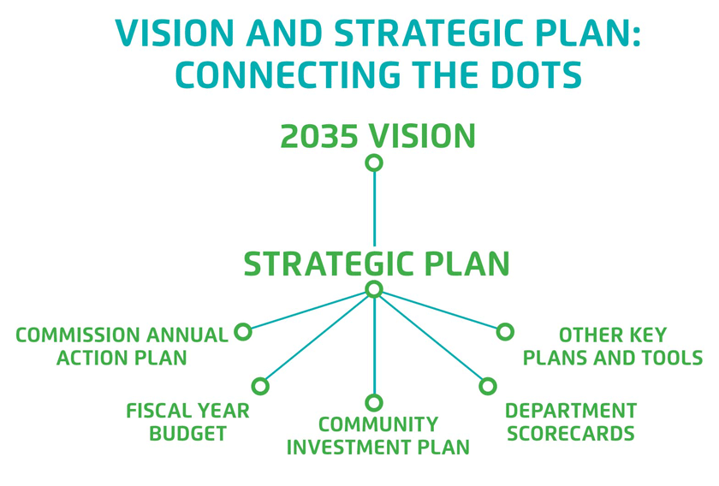
The City has defined a handful of key performance indicators for each of the six vision plan categories, such as walkability score as an indicator of “We are Connected” and pavement condition as an indicator of “We are Ready.” Each indicator is evaluated for a baseline measurement and has a five-year target. The Strategic Plan also contains performance indicators and five-year targets for each objective.
City staff explained that the indicators within the Strategic Plan are a subset of a much larger internal database of performance measures that the City continually updates and monitors. The City Manager meets with the directors of the City departments and other leaders every two weeks to discuss the performance measures. These performance measures tie the initiatives within the Strategic Plan to the City’s Community Investment Plan and Commission Annual Action Plan.
Examples of the transportation-related performance indicators include:
- Percentage of residents within 10 minutes walking distance of a park.
  - Five year target = 85%
- Miles of sidewalk and trails
- Sun Trolley ridership
- VMT reduction
- Commuter modal shift
- Walkability score
- Sun Trolley ADA compliance
- Replacement of bus shelters
Some of these measures are simply for monitoring purposes, but they are all updated every two weeks. Fort Lauderdale intends to share select performance measures from the larger internal database with the public through a scorecard.

Bicycle & Pedestrian Indicators
City staff noted that performance measures and indicators are very useful, but collecting data is very expensive, especially for multimodal counts and VMT. It is also difficult to find meaningful measures for bicyclists and pedestrians. The City hired a summer intern who mapped all of the sidewalks in the City, over 30 square miles. The City now has a complete comprehensive inventory and is using this as a starting point to measure newly constructed sidewalks each year with a goal of increasing sidewalk coverage each year.
Fort Lauderdale is in the process of developing prioritization criteria for project selection. The idea is that projects that “help the most people” will be ranked higher. Criteria may include connectivity, safety, and environment, among others.
FDOT shared that the Multimodal Level of Service methodology is evolving. FDOT is going to begin a program to monitor bicycle and pedestrian counts at specific locations over time to assess usage. FDOT is developing the methodology for this program, and they have not yet selected which places to monitor.
City staff noted the challenge of projecting where future bicycle and pedestrian investments should go. Data about current use does not provide insight on future demand. The City mentioned the Cypress Creek Tri-Rail hub as an example.
Fort Lauderdale requires developers to include bicycle and pedestrian amenities through a concurrency program for the street network. Sometimes the developer will provide the amenities in front of the property, other times the amenities may be required off-site. The “rational nexus” legal argument requires a careful balance.

Strategies for Implementation and Coordination
City staff noted that a change in the administration has enhanced the City’s internal coordinating. The various City departments are communicating with each other on a much more regular basis through weekly meetings, which has increased the efficiency of the development review process.

Complete Streets
Fort Lauderdale is working with the Broward MPO and FDOT on Complete Streets. The City recognizes Complete Streets is a multi-agency issue.

All Aboard Florida
All Aboard Florida, the effort for intercity passenger rail along the FEC rail line, has established a city-county working group, in which Fort Lauderdale participates.

Other Coordination Efforts
FDOT District 4’s Complete Streets coordinator and representatives from the Broward MPO have helped in the development of the Fort Lauderdale’s multimodal transportation plan. Fort Lauderdale is working with Wilton Manors and Lauderdale-By-The-Sea on Sun Trolley transit service and transfers.
The City informally coordinates with other localities frequently through phone and email conversations and other collaborative efforts. The City also coordinates with freight rail companies on the FEC passenger service. The City desires to move freight rail from the FEC corridor onto the CSX corridor to “free up commuter capacity.”
Fort Lauderdale is also coordinating with the airport. The City envisions a future connection with the Wave streetcar to the Convention Center, and is talking with the airport about a larger vision.

Strategies and Indicators
The following table lists the strategies and indicators that the City of Fort Lauderdale mentioned throughout the listening session.
Strategies
System-Wide
- Conduct a vision plan with extensive community outreach
- Develop a strategic plan with goals, objectives, initiatives, and performance indicators to achieve the vision
- Identify strategic small steps that can be implemented in the short term that work towards the longer term vision as a transition
Facilities
- Develop a multimodal connectivity plan to determine the bicycle and pedestrian needs, and use these needs in the development of the LRTP and TIP
- Adopt a Complete Streets Policy
- Develop a Complete Streets Manual
- Monitor ridership and expand transit where necessary
- Undertake a program to make all bus stops ADA compliant and replace bus shelters where needed
- Convert parking spaces into parklets to slow down traffic speeds
- Use lane elimination to increase pedestrian safety
Places
- Develop master plans for multimodal districts
- Develop TOD guidelines for multimodal nodes
- Use overlay zoning to streamline the development process for multimodal districts
- Increase allowable densities with land development regulations for multimodal districts
- Conduct an affordable housing study to determine the best policies for including affordable housing in new developments
- Expedite review of B-cycle applications
- Develop a vision plan for TOD with realistic small steps for the short term
- Promote “active building” design to avoid empty space and blank walls by encouraging interesting and engaging building facades
- Conduct a walkability study to determine the short-term low-budget improvements for improving the pedestrian and bicycling environment

Indicators
The City’s Strategic Plan, available online at http://www.fortlauderdale.gov/pressplay includes 142 performance indicators. The City tracks these indicators, as well as other internal performance measures within an internal database that is updated every two weeks.

