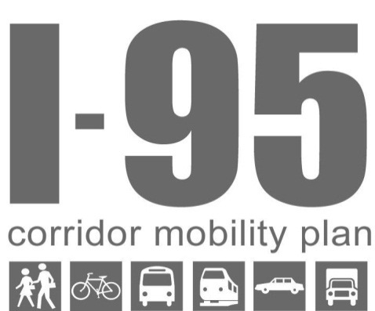
Meeting Summary
The Working Group for the I-95 Corridor Mobility Plan met on February 25, 2013. Nineteen representatives from local governments, local and regional transit agencies, Metropolitan Planning Organizations, and FDOT attended. Most participants had attended the previous Working Group meeting in December 2012.
The purpose of this meeting was to review the project framework from the last working group meeting and discuss the connection between this project’s objectives and local objectives. Meeting materials including handouts, the PowerPoint presentation, and sign-in sheets are available on the project website at http://www.myplanspace.com/i95 (see Documents tab).

Review from Last Meeting & Project Framework
The project team briefly reviewed the project framework presented at the last working group meeting, including the generalized future land use, facility types and functions, and place types and functions. Meeting handouts included the map series of these items and the tables of facility type functions and place type functions.

Naming Conventions
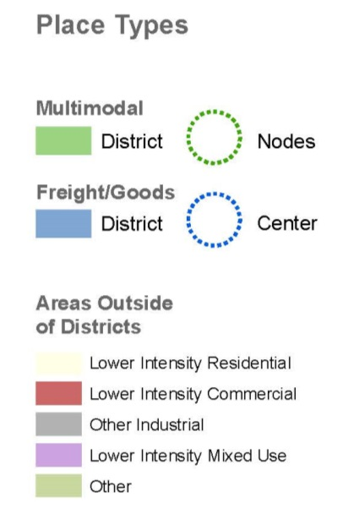
The group discussed the naming conventions of the facility types and place types. Participants considered the relationship between the FDOT functional classification system and the facility types proposed in this plan. Some participants questioned whether the traditional functional classes like principal arterial and collector might be better than the proposed facility types because people are more familiar with them. Other participants explained that each functional class focuses design primarily on the automobile and simply accommodates other modes, whereas the I-95 project is focused on holistically designing complete networks for all modes of transportation, not just the automobile.
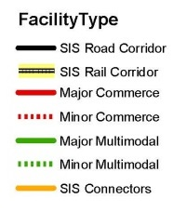
The City of Fort Lauderdale is working on a related effort examining how the typical sections of each functional class can better accommodate pedestrians and bicyclists, primarily through lane reduction. Both efforts aim to place more of a focus on pedestrians, cyclists, and transit. The difference in the efforts is that Fort Lauderdale is working within the traditional functional classification naming conventions, whereas the I-95 project is using a different set of naming conventions. Both initiatives will require planners to designate those corridors that are appropriate for design treatments. Coordination between both efforts will be important to ensure consistency.
SIS Road Corridor
SIS Rail Corridor
Primary Commerce
Commerce
Primary Multimodal
Multimodal
SIS Connectors
The group considered the term corridor as opposed to facility, and replacing the term major with primary and removing the minor term, and consistency with nomenclature in the MPO Long Range Plans. The group reached consensus on the facility type and place type naming conventions shown above. The main takeaway was that the I-95 final report and other project materials must clearly define the terms and naming conventions to avoid confusion. Many of these terms are used in other planning contexts with slightly different meanings; descriptive definitions will help everyone communicate clearly.

Other Comments on the Project Framework
Participants questioned how the SIS connectors will be incorporated and clarified that bicycle and pedestrian connections should be provided on all SIS connectors that are part of the arterial or local road network (i.e., not interstate ramps). In 2009, FDOT evaluated the level/quality of service for bicycles, pedestrians, transit and automobiles for all of the SIS Connectors in Broward County in the SIS Connector Reports, available on the I-95 project website under Background Documents. These SIS Connector Reports identify safety, operational and multimodal improvements and recognize the need for coordination and partnership with local governments and transportation providers.
The project team presented the Aspirational Future Scenario map, which is a refined version of the Data-Supported Multimodal network map realigning some of the Multimodal Nodes and Districts to the FEC Rail corridor. Localities are planning to focus new development into transit-oriented nodes along the FEC Rail stations; this was a major theme from the first working group meeting. The Aspirational Future Scenario map also displays those parcels designated as Regional Activity Centers, Local Activity Centers, Transit Oriented Developments, and Transit Oriented Corridors, and includes the Wave Streetcar and Broward East-West Transit Study alignment as Major Multimodal (now called Primary Multimodal) facilities. The working group agreed that the Aspirational Future Scenario was an accurate representation of the future of the area.
One participant suggested lightening the color of the lower intensity areas on the maps that show the different place types for better visual clarity.

Project Objectives & Local Objectives
The overarching purpose of this plan is to improve mobility within the I-95 corridor and throughout Broward County and southern Palm Beach County, considering both transportation and land use. Transportation and land use have a symbiotic relationship – decisions about one inevitably affect the other. FDOT and the local governments will need to work in partnership to implement the strategies that this plan will ultimately recommend.
Recognizing this inherent partnership, the project team facilitated a brainstorming session on project objectives. Representatives from local governments shared ideas of what they would like the I-95 plan to accomplish and ways in which this effort could support their local initiatives. This open discussion set the stage for collaboration between FDOT and the localities, so that all participants clearly understand the desires of each agency, shared interests, and common end goals that everyone can work towards.
Previous phases of the I-95 project articulated four main goals:
- Support Mobility and Safety Solutions
- Support Community Livability and Planning Initiatives
- Promote Economic Vitality and Growth
- Promote Sustainability Initiatives
Using these four goals as a starting point, participants individually brainstormed project objectives, shared their ideas, and openly discussed what those objectives mean, barriers to achieving these objectives, and opportunities to help overcome the barriers.

Brainstorm of Objectives
Ideas for Project Objectives
- Source for Transit Development Plan
- Work Together for Common Objectives
- Lane Reductions and Multimodal Connectivity
- Implementation of Complete Streets
- Bicycle and Pedestrian Safety
- Reduce Trip Lengths
- Maximize Multimodal Mobility through Master Planning
- Improve Economic Development
- Climate Resiliency
- Facilitate More Recreational Access
- Provide Multimodal Funding Priorities
- Weight Funding Priorities to Reduce VMT and Promote Walkability
- Reduce Dependency on Automobiles
- Increase Level of Service for I-95
- People, Freight & Goods Focus on I-95

Source for Transit Development Plan
Broward County Transit (BCT) is undergoing a ten-year update to the Transit Development Plan (TDP) and sees the I-95 project as a resource for the TDP update. In particular, BCT would like to develop a larger plan for the Community Bus system.
The mapping and analysis for I-95 has identified hotspots of activity along the major transit routes, which will be useful for the TDP update. The maps clearly show where the areas for multimodal investment are, and would be useful as visualizations in outreach efforts on funding sources. One of the barriers in the TDP update, as in other planning efforts, is getting public feedback.
There are many different planning efforts that happen continuously and simultaneously, and each effort usually has its own public involvement component. Interested public citizens can become weary of the process because there are too many meetings and very little results.
Consolidating public involvement efforts would be an opportunity to engage citizens for multiple planning initiatives in a single process. Ideally, public citizens could attend one meeting where representatives from multiple agencies would be available to discuss several different ongoing planning efforts. Representatives could direct those community members who attend in hopes of talking about a particular issue to the appropriate person.

Work Together for Common Objectives
Much of the previous discussion is directly relevant to the idea of working together to achieve common objectives. South Florida’s many individual cities and counties make regional collaboration difficult. In addition to multiple jurisdictions, many actors in the private sector contribute to the complexity. Developing an implementable action plan that brings in the private sector will be critical.
Participants shared reasons why they need better communication and coordination between the localities, planning agencies, and FDOT. In particular, localities want to learn more and share information about funding opportunities. Commuter services had a portal about 15 years ago through which local governments, FDOT, transit providers, and other planning agencies could coordinate. The IPARC system in Palm Beach County is one tool that is available.
Interagency coordination was a key theme of this discussion, and the working group agreed that some sort of coordination and communication tool/strategy would be very useful.

Lane Reductions and Multimodal Connectivity
Several localities have initiatives underway to identify and prioritize needed multimodal connections, including Fort Lauderdale and Wilton Manors. Multimodal connectivity was a key theme.
The City of Fort Lauderdale in particular is identifying facilities where bicycle and pedestrian projects may be possible by reducing the number of travel lanes. Lane reductions are of interest to other localities, and participants desired that the I-95 plan assist with this effort. Participants discussed the benefits and drawbacks of lane reductions, noting successes in other communities, but that they may not be appropriate as determined on a case-by-case basis for certain facility types (e.g. SIS corridors, parallel relievers, or commerce facilities).

Implementation of Complete Streets
Localities and planning councils would like to implement Broward County’s Complete Streets Guidelines. They need a Complete Streets Plan that identifies where the Complete Streets would be implemented.
The process of implementing a Complete Street is a barrier because of the process of obtaining county and/or FDOT approval. Complete Streets concepts need to be incorporated into the Broward County Trafficways Plan and the various land development codes.
Another barrier is simply the fact that 98 percent of people are traveling in single-occupancy vehicles. Meaningful incentives and development requirements to improve multimodal transportation and utilize design features that encourage walking and biking will help. A streamlined common application between FDOT and Broward County would also be useful.

Bicycle and Pedestrian Safety
Pedestrian and bicycle safety was the most commonly voiced objective in the meeting. Participants discussed not only reducing the number of travel lanes, but also travel lane width to provide more space for pedestrian and bicycle facilities.
The process of coordinating plans to reduce lanes or lane widths can be complex, and local governments perceive this process as a barrier, but it offers mutual benefits among agencies.

Other Objectives
Participants raised the following objectives in addition to the previous items. Due to time constraints, conversation about these objectives was limited.
- Reduce Trip Lengths
- Maximize Multimodal Mobility through Master Planning
- Improve Economic Development
- Climate Resiliency
- Facilitate More Recreational Access
- Provide Multimodal Funding Priorities
- Weight Funding Priorities to Reduce VMT and Promote Walkability
- Reduce Dependency on Automobiles
- Increase Level of Service for I-95
- People, Freight & Goods Focus on I-95

Summary of Project Objectives
Several common themes emerged from the discussion about objectives. Pedestrian and bicycle safety is a key priority for the various localities and planning agencies. The working group agreed that enhanced communication for better coordination between localities and the planning would be a valuable improvement, especially if facilitated by a new tool or simple process. Funding opportunities are important to identify. Prioritizing projects and identifying critical locations to streamline implementation would increase efficiency and would be cost-effective. Reducing travel demand and auto dependence was another commonly identified theme.

Local Development Processes and Tools
The working group discussed processes and tools that local governments use to encourage developments to be more multimodal. The local government representatives reiterated the emphasis on the FEC Rail passenger service and trying to focus new development around the station areas with transit-supportive characteristics. Commuter access to these stations is important.
Different communities use different approaches, such as form-based codes, overlays, setting density minimums, Complete Streets, Bicycle & Pedestrian Connectivity Plans, Downtown Master Plans, small area master plans, and design guidelines to transition away from being solely auto-oriented.
For example, the City of Wilton Manors prioritizes areas for transit-supportive development and then identifies alternatives for these areas. They emphasize location of parking to make sure new structures are located near the future transit station. Most cities have a Community Redevelopment Agency (CRA), and the City of Dania Beach in particular has updated its zoning code to be consistent with the CRA master plan.

Next Steps
The project team will consolidate the key themes from the discussion into a list of project objectives. The project team and the working group will develop strategies and performance measures based on these objectives at the next working group meeting.

